Scott's Electric

PO Box 581

Waelder, TX 78959

Office:830-339-0432 Cell:361-827-5127

Scotts_Electric@yahoo.com

Safety Checklist

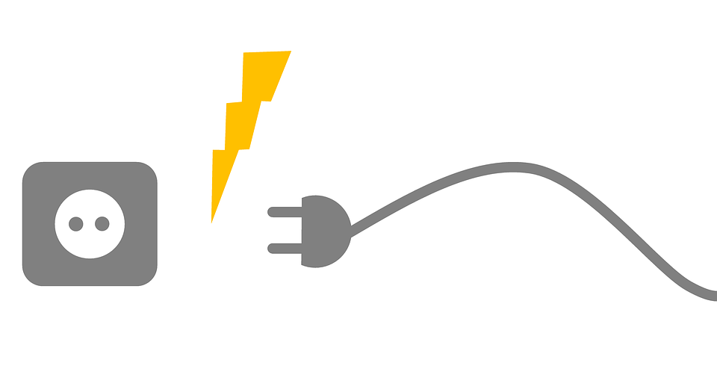
One of electricities most common issues is connections. There is always expansion and contraction arising from the use of electricity due to the heating and cooling of the electrical system. Scotts Electric will check key points in your electrical system to expose potential hazards. Take readings on voltage, amperage, as well as check connections at service panels. We also check the condition of the grounding system. (electrode and electrode conductor)

Complete walk through of structure to check polarity at all outlets. Identify and confirm GFCI function and proper location.

Check location and function of smoke alarms. (if hardwired)

We will make recommendations on actions that should be taken against hazards that are exposed. This check is not an inspection as much as preventative maintenance for your electrical system. Don’t wait until after the fire to have your system checked!!
Scotts Electric Safety Checklist Date __/__/____ Time: __________
Office: 830-339-0432 Scotts_Electric@yahoo.com
Cell : 361-827-5127
Check performed at: Check performed by:

Safety rating- (poor) (Fair) (Good)

The following values are based on normal operating conditions at the date and time the check was performed.
Service:______/______PH_____ SEC:________ GE:_________ GEC:_________ Main Brkr:________
____Check connections at main/subpanels.
____Check volts to N at main panel (A)-phase______(B)-phase______(C)-phase______
Sub panel (A)-phase______(B)-phase______(C)-phase______
____Check volts to Grnd main panel (A)-phase______(B)-phase______(C)-phase______
Sub panel (A)-phase______(B)-phase______(C)-phase______(N)______
____Check Amps at main panel (A)-phase______(B)-phase______(C)-phase______(N)______
Sub panel (A)-phase______(B)phase_______(C)-phase______(N)______
____Check system grounding condition. (poor) (fair) (good)
____Check polarity and stability on outlets throughout the structure.
____Check GFCI function and proper location
____Check smoke alarms function and proper location.
Recommendations:

